Config File Format

What is a Config File Format?
# Source: AI Source: Provided by: [Data Path: Persons Table -> ID Column: 1, Name_En Column: Motasem Essam] -> From: [ChatGPT] on [1/26/2026]
A config file format is the structure or standard used to store configuration data for an application or system.
- Purpose: To tell an application how to behave without changing its code.
- Stored as files in a specific format that programs can read easily.
- Can be simple key-value pairs, structured text, or even XML/JSON/YAML.

Common Config File Formats
# Source: AI Source: Provided by: [Data Path: Persons Table -> ID Column: 1, Name_En Column: Motasem Essam] -> From: [ChatGPT] on [1/26/2026]
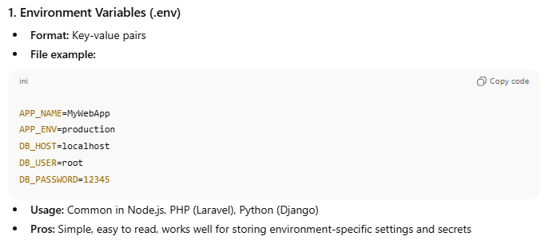

1. Environment Variables (.env)
- Format: Key-value pairs
- File example:
APP_NAME=MyWebApp
APP_ENV=production
DB_HOST=localhost
DB_USER=root
DB_PASSWORD=12345
- Usage: Common in Node.js, PHP (Laravel), Python (Django)
- Pros: Simple, easy to read, works well for storing environment-specific settings and secrets

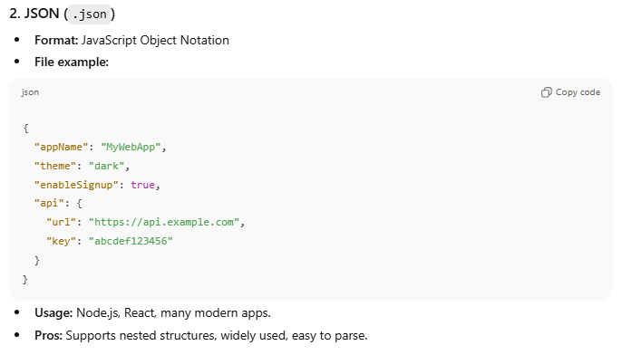
2. JSON (.json)
- Format: JavaScript Object Notation
- File example:
{
"appName": "MyWebApp",
"theme": "dark",
"enableSignup": true,
"api": {
"url": "https://api.example.com",
"key": "abcdef123456"
}
}
- Usage: Node.js, React, many modern apps.
- Pros: Supports nested structures, widely used, easy to parse.

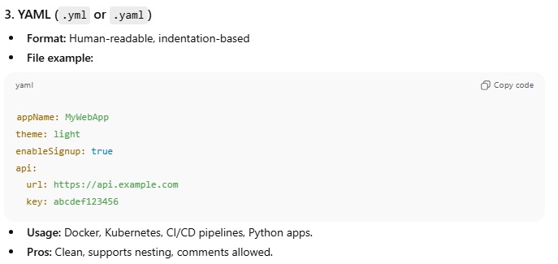
3. YAML (.yml or .yaml)
- Format: Human-readable, indentation-based
- File example:
appName: MyWebApp
theme: light
enableSignup: true
api:
url: https://api.example.com
key: abcdef123456
- Usage: Docker, Kubernetes, CI/CD pipelines, Python apps.
- Pros: Clean, supports nesting, comments allowed.

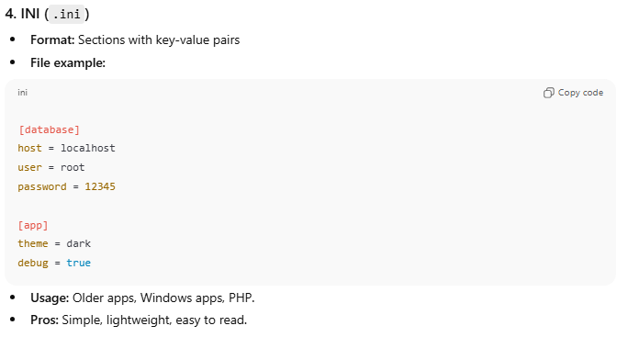
4. INI (.ini)
- Format: Sections with key-value pairs
- File example:
[database]
host = localhost
user = root
password = 12345

[app]
theme = dark
debug = true
- Usage: Older apps, Windows apps, PHP.
- Pros: Simple, lightweight, easy to read.

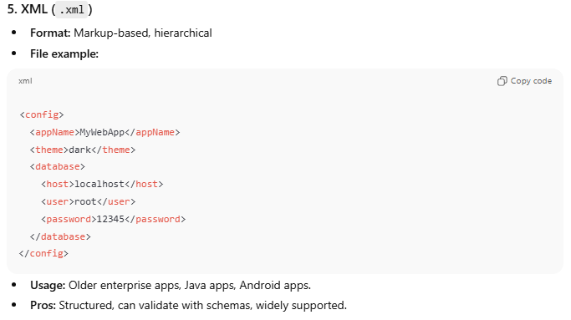
5. XML (.xml)
- Format: Markup-based, hierarchical
- File example:
<config>
<appName>MyWebApp</appName>
<theme>dark</theme>
<database>
<host>localhost</host>
<user>root</user>
<password>12345</password>
</database>
</config>
- Usage: Older enterprise apps, Java apps, Android apps.
- Pros: Structured, can validate with schemas, widely supported.

Comparison Table
# Source: AI Source: Provided by: [Data Path: Persons Table -> ID Column: 1, Name_En Column: Motasem Essam] -> From: [ChatGPT] on [1/26/2026]
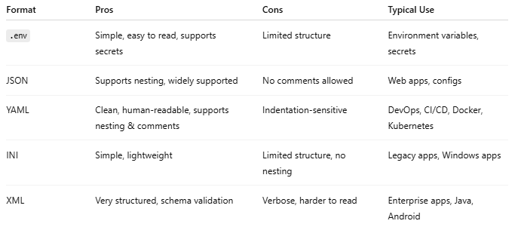

Format | Pros | Cons | Typical Use
.env | Simple, easy to read, supports secrets | Limited structure | Environment variables, secrets
JSON | Supports nesting, widely supported | No comments allowed | Web apps, configs
YAML | Clean, human-readable, supports nesting & comments | Indentation-sensitive | DevOps, CI/CD, Docker, Kubernetes
INI | Simple, lightweight | Limited structure, no nesting | Legacy apps, Windows apps
XML | Very structured, schema validation | Verbose, harder to read | Enterprise apps, Java, Android
Perfect! Let’s make a side-by-side comparison of the same application settings in all 5 config file formats: .env, JSON, YAML, INI, and XML. This is super useful to visualize differences.

Example: Same App Settings in Multiple Config File Formats
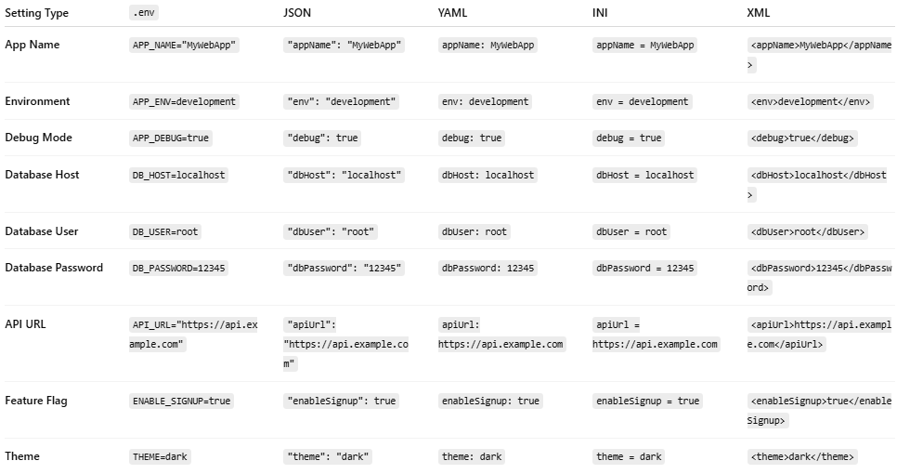
Setting Type | .env | JSON | YAML | INI | XML
App Name | APP_NAME="MyWebApp" | "appName": "MyWebApp" | appName: MyWebApp | appName = MyWebApp | <appName>MyWebApp</appName>
Environment | APP_ENV=development | "env": "development" | env: development | env = development | <env>development</env>
Debug Mode | APP_DEBUG=true | "debug": true | debug: true | debug = true | <debug>true</debug>
Database Host | DB_HOST=localhost | "dbHost": "localhost" | dbHost: localhost | dbHost = localhost | <dbHost>localhost</dbHost>
Database User | DB_USER=root | "dbUser": "root" | dbUser: root | dbUser = root | <dbUser>root</dbUser>
Database Password | DB_PASSWORD=12345 | "dbPassword": "12345" | dbPassword: 12345 | dbPassword = 12345 | <dbPassword>12345</dbPassword>
API URL | API_URL="https://api.example.com" | "apiUrl": "https://api.example.com" | apiUrl: https://api.example.com | apiUrl = https://api.example.com | <apiUrl>https://api.example.com</apiUrl>
Feature Flag | ENABLE_SIGNUP=true | "enableSignup": true | enableSignup: true | enableSignup = true | <enableSignup>true</enableSignup>
Theme | THEME=dark | "theme": "dark" | theme: dark | theme = dark | <theme>dark</theme>

Key Notes:
- .env → Best for environment variables, simple KEY=VALUE, no nesting.
- JSON → Structured, supports nesting, widely used in apps, but no comments allowed.
- YAML → Human-readable, supports nesting & comments, good for DevOps.
- INI → Simple key-value pairs, can have sections [section], limited nesting.
- XML → Verbose but structured, supports complex hierarchy, good for enterprise apps.

💡 Tip:
- For secrets and environment-specific values, use .env files.
- For complex app configs, use JSON, YAML, or XML.
- INI is mainly for legacy systems.

💡 Key takeaway:
# Source: AI Source: Provided by: [Data Path: Persons Table -> ID Column: 1, Name_En Column: Motasem Essam] -> From: [ChatGPT] on [1/26/2026]
Config file format = how configuration data is written and structured. Choice depends on complexity, readability, and platform requirements.

